**MAHENDRA INSTITUTE OF ENGINEERING AND TECHONOLGY**

***SMART WATER MANAGEMENT***

**PROBLEM DEFINING AND DECISIONTHINKING (PHASE-2)**

**TEAM MEMBERS:**

**T.SATHISH KUMAR**

**V.SARAVANAN**

**P.PONVIJAY**

**E.CHANDRU**

**S.HARIHARN**

**CORDINATOR:**

**Mrs. ARUNAA**

**Existing system** **:**

This is used for water level detection and automatic ON/OFF the motor for water tanks. By using IOT the data is upload on Ada fruit platform. Laser sensor is placed above the tank toknowthe level of the water in the tank. When water falls below the threshold value the motor is automatically ON.

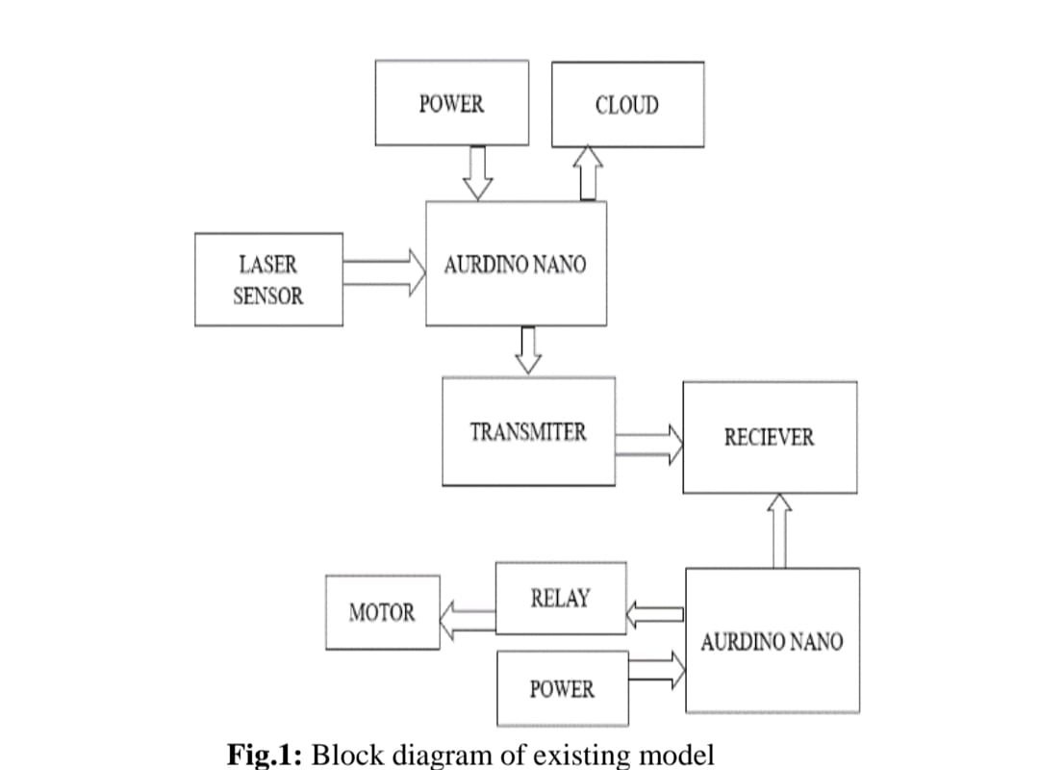

**Proposed System :**

(!) In the proposed system the following parameters can be known

(!!) The level of water in the tank by using the ultrasonic sensor and can reduce overflow of the water.

(!!!) The usage of the water in the tank can be used to control the wastage of the water. To know the temperature in the water tank in real time .

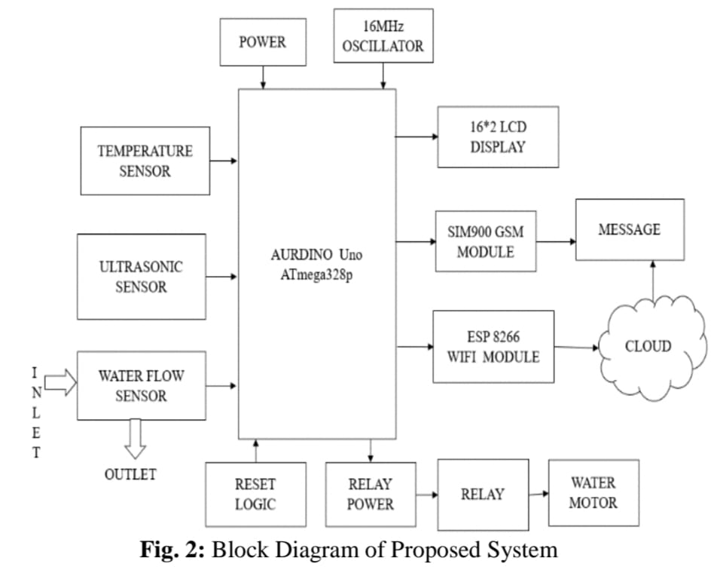

The DDC can be linked to a router and used as a local Wi-Fi network or connected to the internet. In the case of a local network, people can use a smart app or a web browser on a connected device to access it directly through that network. The DDC is linked to the cloud server using the internet connection option. People get additional functionality when using the cloud server option by storing data on a remote cloud server. People can use the smart app or browser to send DDC instructions or get status information by establishing a cloud server connection. It is possible to keep the cloud server’s pump and water level history if needed. An efficient water management system is essential for overcoming the difficulties associated with water shortages. Management of water resources is made feasible via continuous monitoring of quantity and quality. Monitoring water levels in real time may drastically reduce water waste caused by overflowing storage tanks.

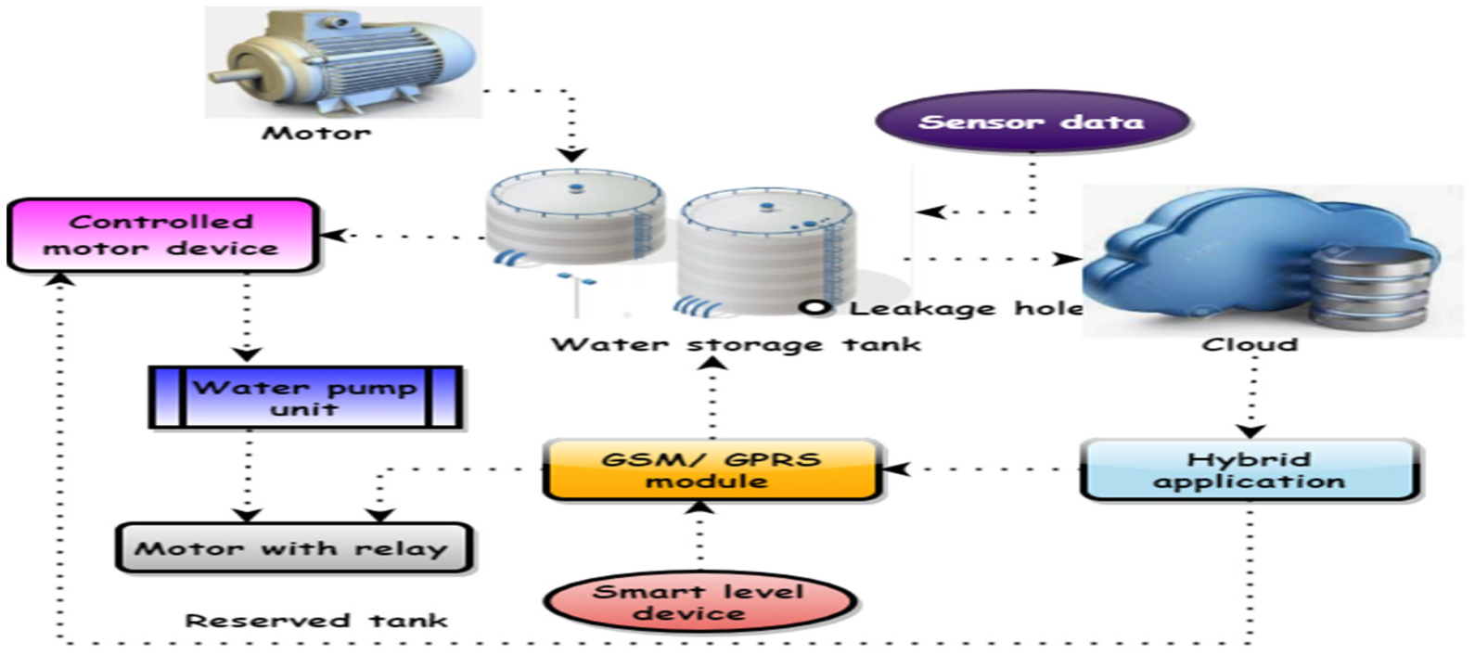

**[Figure 2](https://www.mdpi.com/2227-9717/10/11/2462#fig_body_display_processes-10-02462-f002)** shows the IoT-based smart water management systems. Three-phase pumps, as previously indicated, are often used in water management systems for high-rise structures. This can lead to tanks being overfilled or pumps being overworked, which wastes water and energy and shortens the life of the pumps. For this reason, an intelligent water management system was created that can be used alone or as part of a larger building management system (BMS). Water level sensors in different tanks were linked to a direct digital controller (DDC), which controlled the whole system. The DDC controls the pumps through the pump panel to which it is connected. People can remotely operate the pump and check tank levels using a smart app with a DDC. It needs to be linked to a local Wi-Fi network or the internet to attain this purpose.

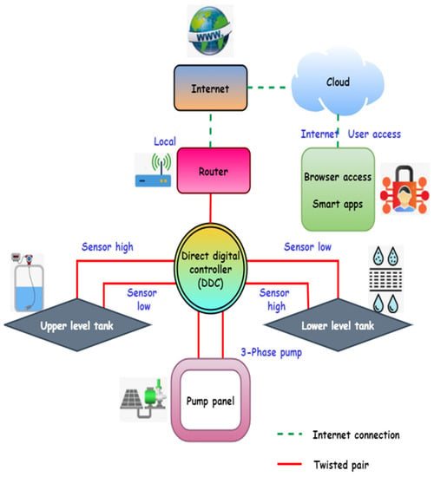

By comparing the water levels at various times of day, the water management system may aid in detecting water leaks in a smart house.

Water leaks and overflows can be spotted in real time with the help of monitoring equipment. Keeping up with real-time data demands a constant data connection and a lot of juice. The Internet of Things has drastically altered how we do research and make predictions. Internet of Things (IoT) can be integrated into a water management system to forecast the amount of water needed by a smart house or campus at various times of the day and throughout the year. The same method can be used to meet the water needs of the campus’s numerous structures. Similarly, studying and anticipating how things like a wet season may affect water quality is possible.